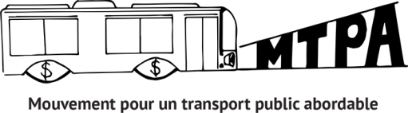
INFORMATION BULLETIN
19th edition- October 2021

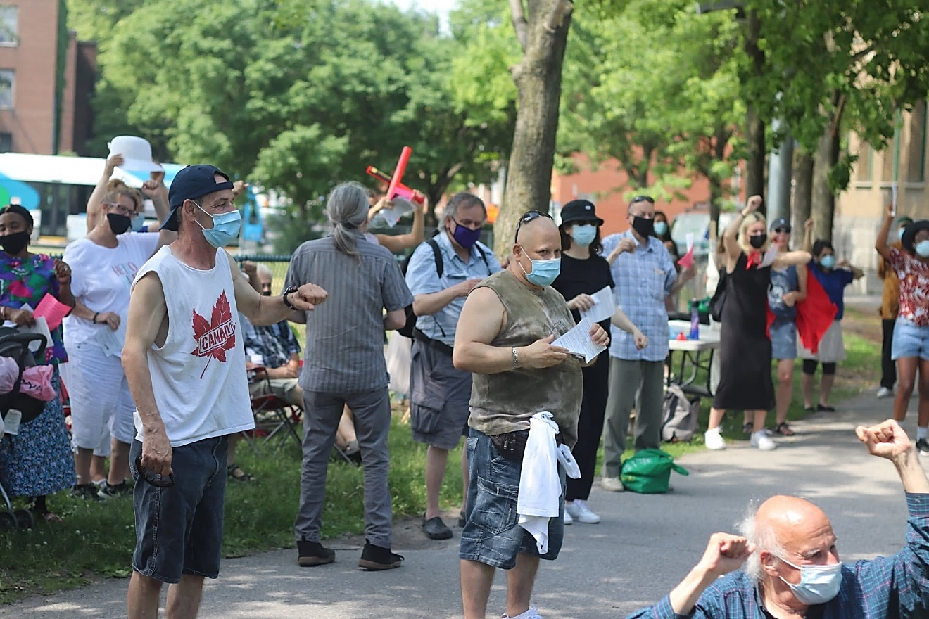
REVIEW OF THE JUNE 8 ASSEMBLY 2
IN THIS ISSUE

THE MTPA IN SHORT
The Mouvement pour un transport public abordable (MTPA) has been working since 2012 on a key issue for a significant portion of the population: affordable access to public transit.
MUNICIPAL ELECTIONS AND A SOCIAL FARE 3

SUPPORTING A SOCIAL FARE DURING THE ELECTIONS 5
DEMO ON NOVEMBER 3RD 8

NEWS FROM THE NATIONAL COALITION 9

BECOMING A MEMBER 10
A social fare in Montreal: Back to the Future?
  - REVIEW OF THE JUNE 8 ASSEMBLY

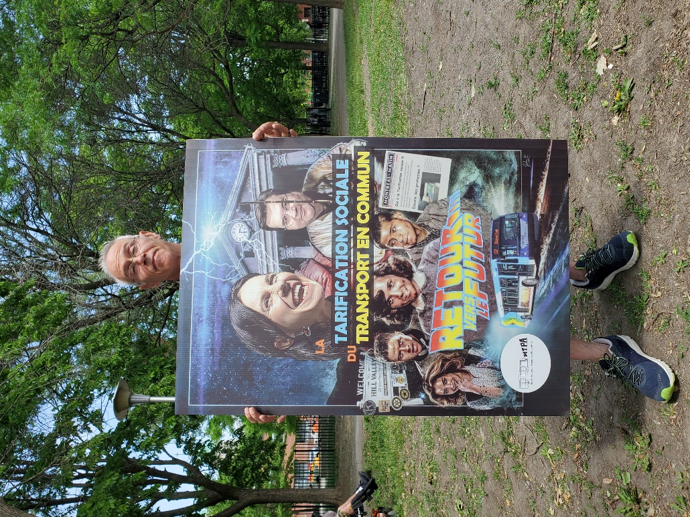
This past June 8, the MTPA held its 8th assembly for a social fare.
We gathered in large numbers to demand that Valérie Plante and Denis Coderre, Montreal mayoral candidates, renew their commitment to implement income-based social fare for public transit. A declaration on this subject was ready to collect signatures of support.
We also revisited the history of our struggle with a famous choreography!

Thank you to everyone that participated!

To read our press release: Social fare for public transit: Back to the Future?
Check our Facebook page to see our photo album from the event.
Michel Tourigny from Comité des sans-emploi de Pointe-St-Charles holding a poster from the rally

  - WHY A BACK TO THE FUTURE THEME?
- Because the more we find ourselves in a situation of poverty, the more difficult it is to access transportation and to get around.
- Because getting around is essential to meet one's needs, whether it be to look for a job, go to the food bank, visit relatives, or go to a medical appointment, etc.
- Because being limited in one's mobility contributes to the social exclusion and isolation of low-income people.
- Because in 2017 Valérie Plante and Denis Coderre had already committed to implement a social fare, which has yet to be done.

We don't want to replay the same movie over again!

MUNICIPAL ELECTIONS AND A SOCIAL FARE

WE DON'T WANT TO REPLAY THE SAME MOVIE OVER AGAIN!
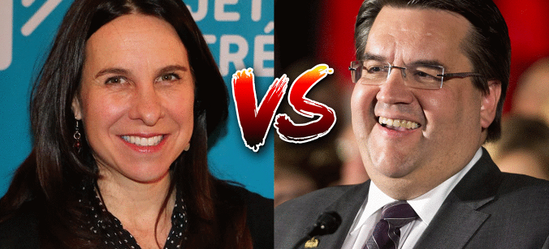

  - Concerns about public transit came out strongly in the fall 2017 municipal elections, both in Montreal and in other municipalities in Quebec. In Montreal, Projet Montréal, like Équipe Coderre, now renamed Ensemble Montréal, had included in their election platforms the promise of a social fare for public transit.
  - During its mandate, Projet Montréal reaffirmed its support for a social fare based on income, but did not take concrete action in this direction. This administration has, however, extended access to student fares beyond age 25 (when studying full-time) and recently announced the passing of the senior fare to a 70% reduction.
  - We know that the 2021 mayoral race will have the same two protagonists, so let's make sure we don't go backwards by getting them and their party to make solid commitments to the social fare for low income populations and people living in poverty!

THE MAYOR OF MONTREAL, THE CMM AND THE ARTM
It should be remembered that the person elected as mayor of Montreal gets to chair the Communauté du Montréal métropolitain (CMM) and that the CMM sits on the board of directors of the Autorité régionale de transport métropolitain (ARTM), which makes decisions on public transit fares.
Another interesting element in the struggle for affordability of public transit is the recommendations of some municipalities to maintain their autonomy of choice on the implementation of a social fare policy found in the report The ARTM tariff redesign - Consultation report (p. 44). Thus, although integrated into the ARTM's fare structure, a municipality could go ahead with a social fare measure in its city... The City of Montreal stood out on this subject by emphasizing "the urgency of implementing solutions to facilitate access to mobility for the most vulnerable populations and by insisting that reflection on the subject be accelerated." (p.43)
Therefore, despite the arrival of the ARTM in the landscape and the implementation of harmonized transportation fares on the territory of Greater Montreal, the November 7 elections remain an opportunity to question the candidates and parties on their commitments to social fares and to bring this demand locally and regionally.

What Denis Coderre has said about a social fare:
« Montreal mayoral candidate Denis Coderre intends to change the fare structure for public transit services to include a social fare»

-Journal Métro, 9 octobre 2013
http://journalmetro.com/denis-coderre-veut-creer-un-tarif-social-pour-les-transports-en-commun/

« You can be sure that my administration intends to adopt a global and metropolitan vision on the subject of social pricing, by dealing jointly with all the players in the region.»

-lettre de Denis Coderre au MTPA, 11 août 2016

What Projet Montréal and Valérie Plante have said about a social fare:

«Richard Bergeron [then head of Projet Mtl] said he wanted to offer a reduced transit fare to all low-income Montrealers. »

-Journal Métro, 16 octobre 2013
http://journalmetro.com/actualites/montreal/bergeron/

« Social pricing for public transit has already been on Projet Montréal's agenda for several months, with party members adopting the measure at a convention last May.»
-Radio-Canada, 29 août 2017
https://ici.radio-canada.ca/nouvelle/1058782/tarification-sociale-transport-commun-metro-bus-montreal-artm-stm

« The mayor intends to take advantage of the establishment of the Autorité régionale de transport métropolitain (ARTM), which now manages the development of public transportation in the region, to extend social pricing to the entire region.»
-La presse, 22 février 2018
Plante pour la tarification sociale dans toute la grande région de Montréal

How to support the social fare in an election period?
THERE ARE MANY OPTIONS !

LETTER-WRITING CAMPAIGN TO CANDIDATES FOR BOROUGH COUNCIL

The MTPA invites you to write to your candidates in order to obtain their commitment to the implementation of a social fee based on income.
Three sample letters (one to Projet Montréal candidates, one to Ensemble Montréal candidates, one to Mouvement Montréal candidates) are available to your group.
You just have to :
- Modify them to your liking
- Send them to your candidates for the mayor's office of your borough with a copy to the MTPA
- Keep us informed of the answers you receive
You will find the letters here : lettres-types campagne municipale
You will find a directory of candidates here: https://elections.montreal.ca/fr/electeurs-trices/repertoire-des-candidats/
For Projet Montréal candidates' emails:
https://projetmontreal.org/equipe?arrondissement
For Ensemble Montréal's candidates' email: https://ensemblemtl.org/equipe/
The only email available for Mouvement Montreal : info@mouvementmtl.com

HOW TO CHALLENGE CANDIDATES ON THE SOCIAL FARE?
In the current electoral context in Montreal, the MTPA solicits the support of your organization and suggests that you question the candidates in your neighborhood during the debates and meetings in which you will participate.
Here are some tips:
As an essential public service, public transportation must be accessible to all. These public services are the responsibility of municipalities, which have a duty to treat their citizens fairly and equitably. Fares must therefore take income into account, so that no one is excluded, even people with low income population and people living in poverty.
Public transit fares are too expensive, and they are a barrier to travel for people living in poverty. High fares become a source of isolation and social exclusion. The ability to travel is essential to meet one's needs and is a condition for the exercise of many rights.
Moreover, public transportation services are an essential tool in the fight against climate change, but they affect people in precarious situations the most.
As a solution to this problem, we believe in the need for social pricing based on income for low income population and people living in poverty. Moreover, Valérie Plante and Denis Coderre already committed in 2017 to implement social fare, which has not been done!

SUGGESTION OF QUESTION
Will you commit to:
- Implement an income-based social fare system that offers low-income households a substantial reduction on public transit fares in Montreal?
- Find the necessary means to implement and sustain this affordability measure?
What strategies will you deploy?

Quick Action, Wednesday, November 3rd
At 1 :30PM, AT PLACE VAUQUELIN (HÔTEL DE VILLE)
Join us for a group photo blitz.
The photos taken at this event will be used for our welcome messages to newly elected municipal officials.
More details to come!

[The social fare : A promise that will haunt you]

Illustration : ghost on a stick by Gigi Perron

NEWS FROM THE NATIONAL COALITION FOR A SOCIAL FARE IN TRANSPORT
The National Coalition for a Social Fare in Transport is an inter-regional coalition of organizations based in different regions of Quebec that are concerned about the impact of the cost of public transportation on people living in poverty across Quebec.
The member organizations are :
- Action populaire Rimouski-Neigette
- Coalition montérégienne pour la tarification sociale du transport en commun (CMST)
- Collectif pour un transport abordable et accessible à Québec (TRAAQ)
- le Mouvement d’éducation populaire autonome de Lanaudière (MÉPAL)
- le Regroupement des organismes d'éducation populaire autonome de la Mauricie (ROÉPAM)
- Trajectoire Québec

In view of the upcoming municipal elections to be held this fall across Quebec, the national committee will launch a joint declaration for social fare of public transit in Quebec municipalities and regions.
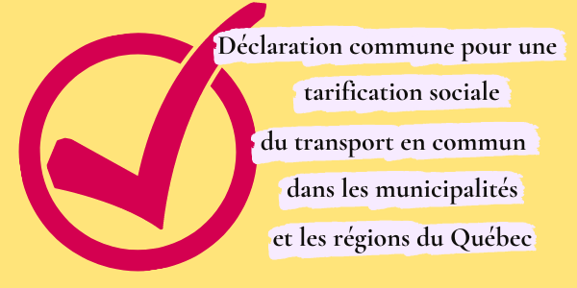
Le The MTPA, along with the National Coalition for Social Pricing in Transportation, is calling on municipal candidates to commit to income-based social pricing. Follow this link to read the statement and add your support: link to the statement.

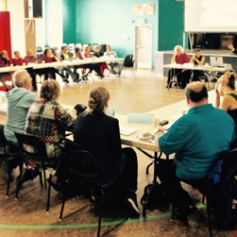
HOW TO BECOME A MEMBER?
Your group must complete the membership form available on our website and at the following link: membership form. The financial contribution is voluntary and another form is available for this purpose.

You will also find it on our website, following the same link as the membership form.
THE MTPA FOLLOW-UP COMMITTEE IS COMPOSED OF: Action-Gardien, AQDR Saint-Michel, CÉDA, Comité des sans emploi de Pointe-Saint-Charles, Project Genesis, TROVEP Montreal and Welfare Rights Committee of South-West Montreal.
To contact us: transport.abordable@gmail.com
OUR MEMBERS

- ACEF du Nord
- Action Autonomie
- ADDS-MM
- AQDR de la Pointe-de-l’île
- Afrique au Féminin
- Atelier des lettres
- Carrefour d’éducation populaire de Pointe-Saint-Charles
- CDC Solidarités Villeray
- CDC de Rivière-des-Prairies
- Centre d’éducation et d’action des femmes (CEAF)
- Centre de lecture et d’écriture
- Centre des femmes d’ici et d’ailleurs
- Centre des femmes de Laval
- Centre des femmes de Verdun
- Centre des femmes solidaires et engagées
- Centre de ressources éducatives et communautaires pour adultes (CRÉCA)
- Coalition Climat Mtl
- Coalition Montréalaise des tables de quartiers (CMTQ)
- Comité d’action de citoyennes et citoyens de Verdun (CACV)
- Comité logement Lachine-Lasalle
- Comité de lutte à la pauvreté du Grand Châteauguay
- Concertation en développement social de Verdun (CDSV)
- Ex aequo
- Femmes du monde à Côte-des-Neiges
- Groupe Alpha Laval
- Imagine Lachine Est
- La Jarnigoine
- La Marie Debout
- La Maison Benoît Labre
- Lettres en main
- Le Tour de lire
- Maison St-Dominique
- Maison Passages
- Mouvement Action-Chômage
- Projet suivi communautaire
- Projet P.A.L.
- RACOR en santé mentale de Mtl
- Regroupement des organismes familles de Mtl (ROCFM)
- Regroupement des usagers du transport adapté et accessible de l’île de Mtl (RUTA)
- Table de concertation des aînés de Mtl (TCAIM)
- Table régionale des centres de femmes de Mtl métropolitain et Laval (TRCFMML)
- Travail de rue et action communautaire (TRAC)

