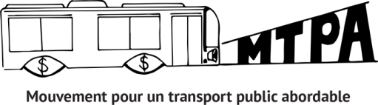
NEWSLETTER
18th edition - September 2020

EVERYTHING ABOUT THE ARTM CONSULTATIONS

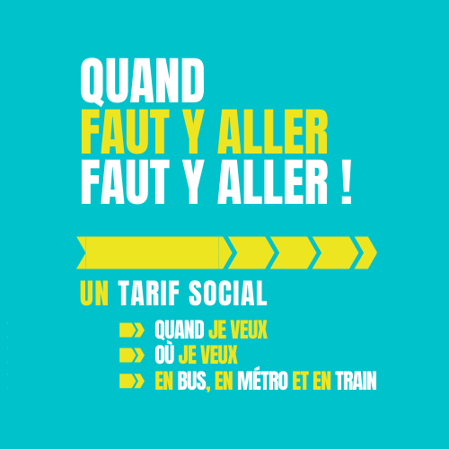

LATEST NEWS ON THE SOCIAL FARE AND THE ARTM 2
MTPA, IN SHORT
Since 2012, the movement for affordable public transport (MTPA, in French) works on an essential question for an important part of the population : financial accessibility for public transport
CONSULTATION DETAILS 3
THE MTPA’S ACTION PLAN FOR THE CONSULTATIONS 5
CALL TO ACTION : HOW TO PARTICIPATE! 6

In our July newsletter, we informed you that the social fare for low-income people was still being considered by the ARTM, but separately from their reform project. Now that consultations on the fare reform have been launched, we have a lot of questions about what will happen next.

LATEST NEWS ON THE SOCIAL FARE AND THE ARTM
In the consultation document made public on September 3rd, the ARTM explains that for now, they are still evaluating the cost and impacts of the different social fare options and that the results of this analysis should be made available soon. In the “Other components of fare reform“ part of the consultation document there is a section about the social fare. Toward the end, it reads:
“The adoption of a social fare scheme strategy remains an important discussion topic that will be part of a collective reflection process over the coming year. Further to discussions with its partners, the ARTM will make recommendations by the end of 2021.“
There is also some reassurance on how “any comments or opinions on social fare schemes expressed during the fare reform consultation may enhance our reflections on this topic.”
For now, we do not know what format will be used for this “collective reflection” on the social fare. However, you can count on the MTPA to remind the ARTM the importance of the social fare in the brief that we will send in and to maintain the pressure so that they make mobility rights for low-income people a priority.

You can consult page 24 of the fare reform consultation document to see what they had to say about the social fare : ARTM-reform project-consultation document

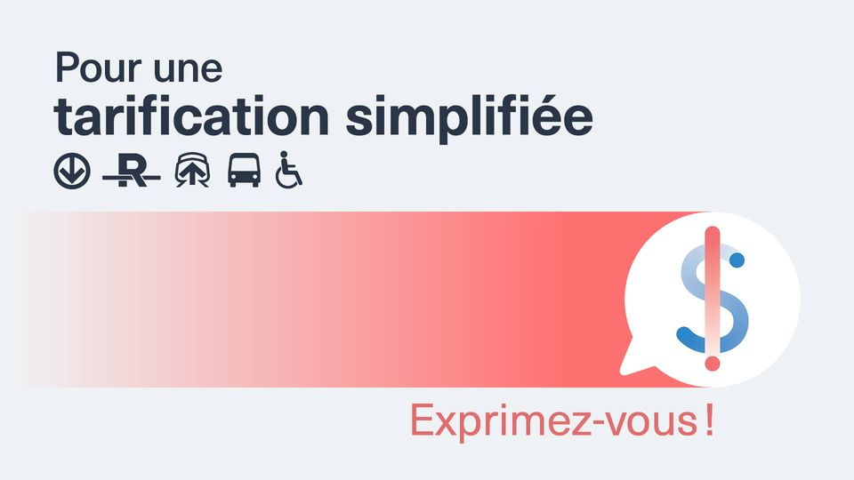
THE ARTM IS RETHINKING MOBILITY WITH ONLINE CONSULTATIONS

On September 3rd, the ARTM finally announced the consultation about the fare reform, which we had been awaiting for almost 3 years. The MTPA was very disappointed after learning that the consultation would only be online and that the deadlines were very tight.
To read the ARTM’s announcement (in French) : L’ARTM annonce le lancement de la consultation publique sur le projet de refonte tarifaire
Next stages announced
Launching of public consultations: September 3, 2020
Request for briefs submissions: September 3 – October 5, 2020
Online info sessions: Between September 8 and 18, 2020
Online consultation: September 8 – October 9 2020
Brief hearings: Between October 12 and 23, 2020
Publication of consultation report: December 2020
Revision of fare reform project to be
adopted by the Board of the ARTM: December 2020

Adoption of the fare reform by the Board: December 2020
Introduction of the first wave of fare simplification: July 1st, 2021
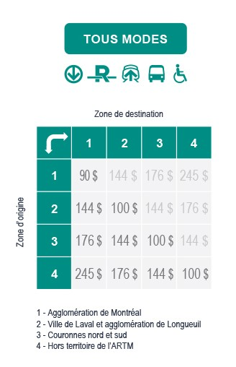
Reform project and consultations
The objective of the fare reform is to simplify fares in the territory of Great Montreal.

The consultation is one scenario that :

- Reduce the territory to 4 fare zones
- Propose fares that give access to all the transport modes, defined by each zone
- Includes a new fare called “bus partout” (bus everywhere)

The website Repensons la mobilité is the place to find all the information to participate in the online consultations. (Unfortunately, the site is mostly in French. For resources in English, click on the English tab on the website).

There, we can :

- Give our opinion about each element of the proposed scenario: Repensons la mobilité- consultation en ligne
- Send suggestions through the ‘ideas box’ Repensons la mobilité- boîte à idées. You can send your own idea or support existing ones, like the one by the MTPA!
- Have access to the consultation document (in English): ARTM-Projet de refonte tarifaire-document de consultation
- Send in a brief (deadline : October 5 at 5 :00 PM): Repensons la mobilité- déposer et présenter un mémoire
- Sign up for the online hearings to present briefs
The brief hearings will take place without an audience, but they will be streamed online. A service for translation into Quebec Sign Language will be available, but one must send in a request before October 9 to this address: refontetarifaire@artm.quebec

OUR ACTION PLAN FOR ARTM CONSULTATIONS

HOW CAN YOU TAKE PART AND GET INVOLVED IN THE ACTION PLAN?
- SUPPORT THE OPINION of the MTPA which uses the main ideas of the brief (Details p. 6)
- JOIN THE CAMPAIGN “WHEN YOU NEED TO GO, NEED TO GO!” (Details p. 7)
- VOTE ON THE MTPA'S COMMENT ON THE NEED TO SET UP A SOCIAL FARE IN THE ARTM ONLINE IDEA BOX: Let's rethink mobility - idea box

SOCIAL FARE BROCHURE 101
To better understand the social fare of public transport.
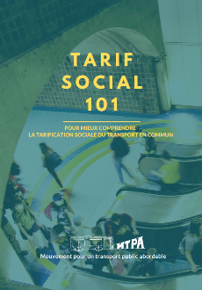
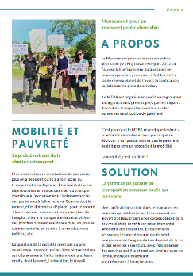
Now available on the MTPA website!
(Documentation section)

Social fare 101- to better understand the social Fare of public transport

NOTICE TO SUPPORT SOCIAL INCOME-BASED FARE
The MTPA invites your organization to support a notice that outlines the brief that will be filed and presented to the ARTM.
You will find the notice attached to this newsletter.
HOW TO SUPPORT?
We invite you to :
• Modify the notice at your convenience
• Add your logo
• Sign it as is if you wish.
• Send it to:
Autorité régionale de transport métropolitain (ARTM)
700 rue De La Gauchetière Ouest, 4e étage
Montréal (Québec) H3B 5M2
or
Via the website : https://repensonslamobilite.quebec/project/appel-de-memoire/collect/depot, but you will have to register to the site and login
Please, send it to us too : transport.abordable@gmail.com
Ideally, participate by October 5, when the ARTM's call for submissions ends. However, do not hesitate to send it even after this date!

INDIVIDUAL SUPPORT CAMPAIGN
When You Have to Go, You Have to Go!!!
BECAUSE GETTING AROUND IS NOT A CHOICE!
You will find the document to support individually in the appendix of this newsletter.
HOW TO SUPPORT?
We invite you to :
• Distribute the campaign document to your participants
• Invite them to sign it
• Invite them to write their comments
• Send it to:
Autorité régionale de transport métropolitain (ARTM)
Boîte à idées sur le projet de refonte
700 rue De La Gauchetière Ouest, 4e étage
Montréal (Québec) H3B 5M2
or
Via the website : Repensons la mobilité- boîte à idées
- It is also possible to comment and vote on ideas already online, including that of the MTPA! Registration on the website is required for this.
- Please let us know of your contribution : transport.abordable@gmail.com
Ideally, participate by October 5, when the ARTM's call for submissions ends. However, do not hesitate to send it even after this date!
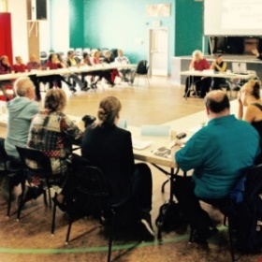
HOW TO BECOME A MEMBER?
Your group must complete the membership form available on our website and at the following link: membership form. The financial contribution is voluntary and another form is available for this purpose.

You will also find it on our site, by following the same link as for the one for the membership form.
THE MTPA FOLLOW-UP COMMITTEE IS COMPOSED OF:
Action-Gardien, AQDR Saint-Michel, CÉDA, Comité des sans emploi de Pointe-Saint-Charles, Mouvement Action-Chômage de Montréal, Projet Genèse, TROVEP Montréal et Welfare Rights Committee of South-West Montreal.
TO Email us : transport.abordable@gmail.com

OUR MEMBERS

- ACEF du Nord
- Action Autonomie
- ADDS-MM
- AQDR de la Pointe-de-l’île
- Afrique au Féminin
- Atelier des lettres
- Carrefour d’éducation populaire de Pointe-Saint-Charles
- CDC Solidarités Villeray
- CDC de Rivière-des-Prairies
- Centre d’éducation et d’action des femmes (CEAF)
- Centre de lecture et d’écriture
- Centre des femmes d’ici et d’ailleurs
- Centre des femmes de Laval
- Centre des femmes de Verdun
- Centre des femmes solidaires et engagées
- Centre de ressources éducatives et communautaires pour adultes (CRÉCA)
- Coalition Climat Mtl
- Coalition Montréalaise des tables de quartiers (CMTQ)
- Comité d’action de citoyennes et citoyens de Verdun (CACV)
- Comité logement Lachine-Lasalle
- Comité de lutte à la pauvreté du Grand Châteauguay
- Concertation en développement social de Verdun (CDSV)
- Ex aequo
- Femmes du monde à Côte-des-Neiges
- Groupe Alpha Laval
- Imagine Lachine Est
- La Jarnigoine
- La Marie Debout
- La Maison Benoît Labre
- Lettres en main
- Le Tour de lire
- Maison St-Dominique
- Maison Passages
- Projet suivi communautaire
- Projet P.A.L.
- Projet Genèse
- RACOR en santé mentale de Mtl
- Regroupement des organismes familles de Mtl (ROCFM)
- Regroupement des usagers du transport adapté et accessible de l’île de Mtl (RUTA)
- Table de concertation des aînés de Mtl (TCAIM)
- Table régionale des centres de femmes de Mtl métropolitain et Laval (TRCFMML)
- Travail de rue et action communautaire (TRAC)

